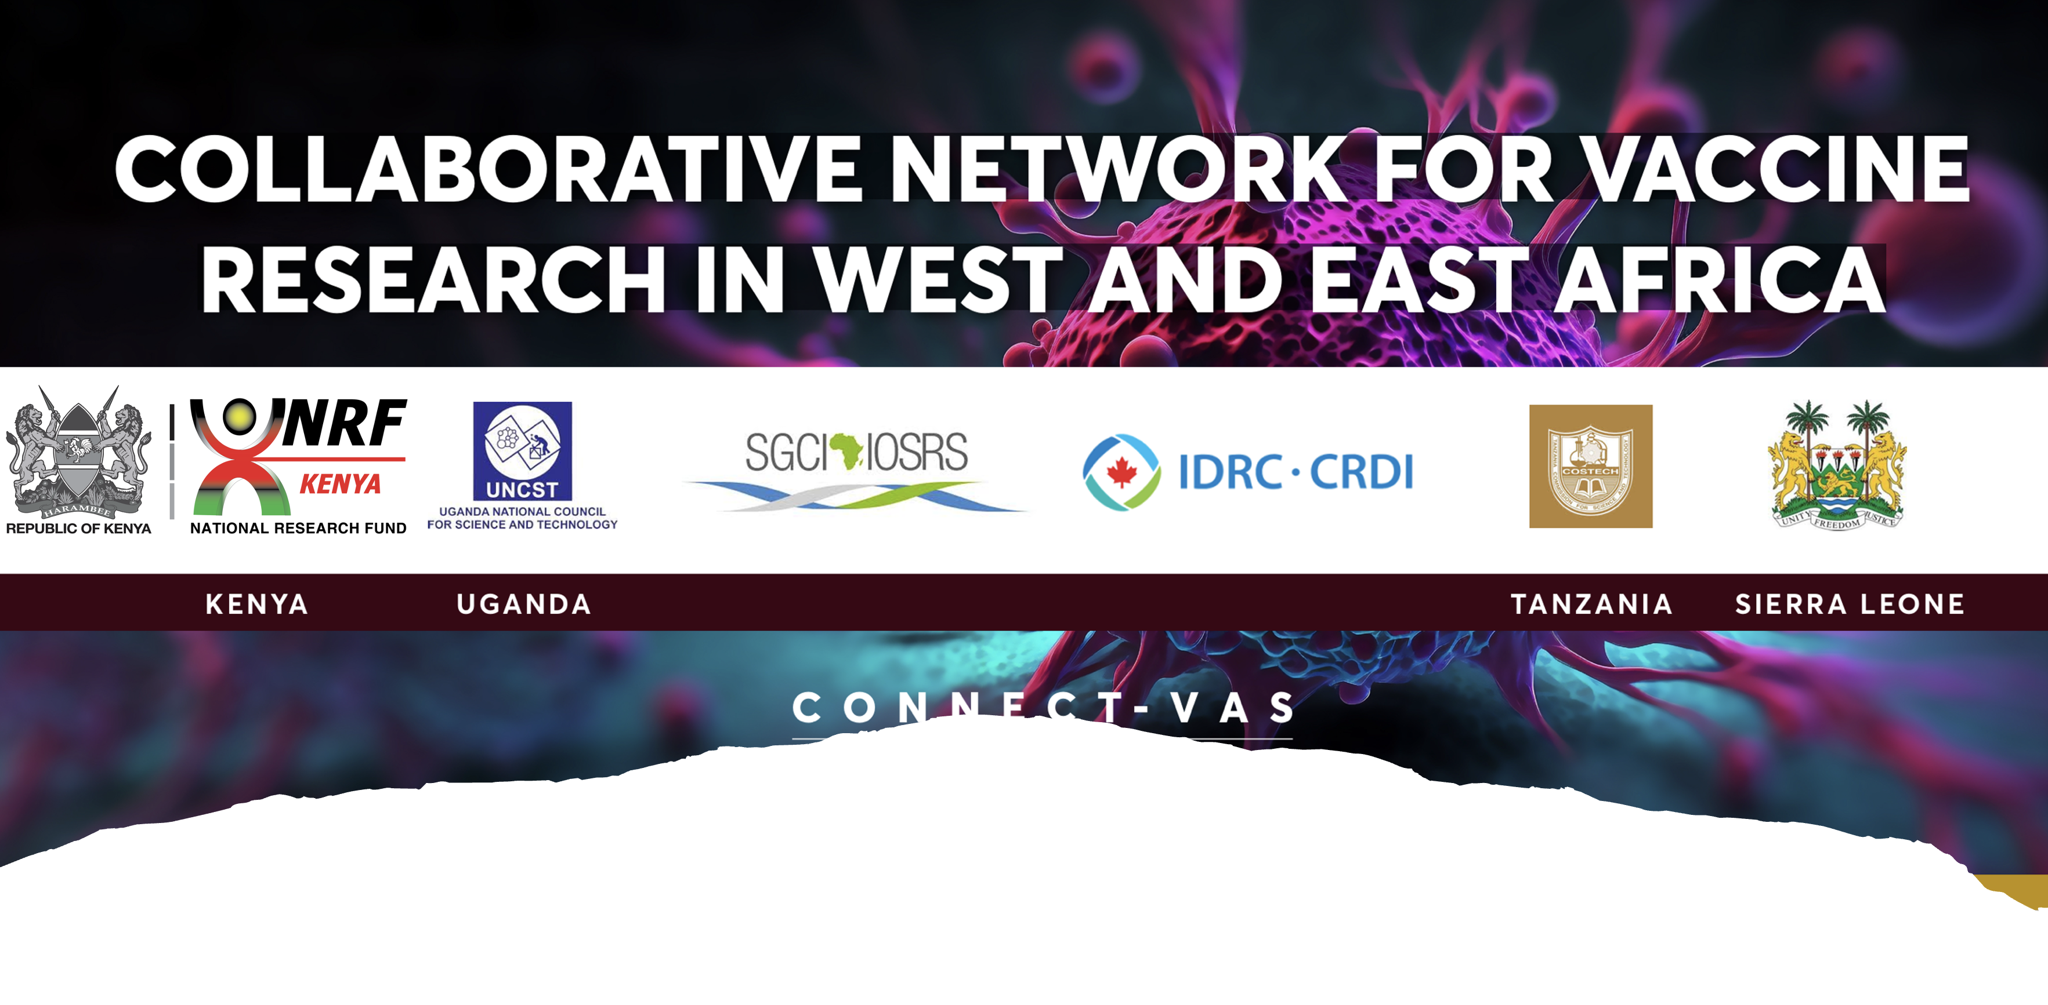
Application Template
________________________________

- All text in blue are guidelines to complete a section and will assist the assessment of the application.
- Researchers (and/or research teams) should ensure that all sections of the application form are completed in full.
- Incomplete forms will not be submitted for review.

PART 1:
GENERAL INFROMATION
Title of the research project (concise)
Project acronym
Keywords (Not more than 5 words)
Contribution to national, regional and international priorities
Publishable summary of the research project. Should be understood to both scientific and non-scientific audiences (not more than 200 words)

PART 2:
PROJECT TEAM MEMBERS
Research Team Member 1
Title
Surname
Name
Age
Gender
Country
Institution
Department
Contact Details
Telephone
Email
Physical address
Role in project
Any Disability |  | YES/NO |  | (if YES, please details)
Curriculum Vitae (CV) attached? |  | YES/NO |  | (if NO, please provide reason here)
Research Team Member 2
Title
Surname
Name
Age
Gender
Country
Institution
Department
Contact Details
Telephone
Email
Physical address
Role in project
Any Disability | YES/NO |  | (if YES, please details)
Curriculum Vitae (CV) attached? | YES/NO |  | (if NO, please provide reason here)
Research Team Member 3
Title
Surname
Name
Age
Gender
Country
Institution
Department
Contact Details
Telephone
Email
Physical address
Role in project
Any Disability | YES/NO |  | (if YES, please details)
Curriculum Vitae (CV) attached? | YES/NO |  | (if NO, please provide reason here)
Research Team Member 4
Title
Surname
Name
Age
Gender
Country
Institution
Department
Contact Details
Telephone
Email
Physical address
Role in project
Any Disability | YES/NO |  | (if YES, please details)
Curriculum Vitae (CV) attached? | YES/NO |  | (if NO, please provide reason here)
Research Team Member 5
Title
Surname
Name
Age
Gender
Country
Institution
Department
Contact Details
Telephone
Email
Physical address
Role in project
Any Disability | YES/NO |  | (if YES, please details)
Curriculum Vitae (CV) attached? | YES/NO |  | (if NO, please provide reason here)
Research Team Member 6
Title
Surname
Name
Age
Gender
Country
Institution
Department
Contact Details
Telephone
Email
Physical address
Role in project
Any Disability | YES/NO |  | (if YES, please details)
Curriculum Vitae (CV) attached? | YES/NO |  | (if NO, please provide reason here)
Research Team Member 7
Title
Surname
Name
Age
Gender
Country
Institution
Department
Contact Details
Telephone
Email
Physical address
Role in project
Any Disability | YES/NO |  | (if YES, please details)
Research Team Member 8
Title
Surname
Name
Age
Gender
Country
Institution
Department
Contact Details
Telephone
Email
Physical address
Role in project
Any Disability | YES/NO |  | (if YES, please details)
Curriculum Vitae (CV) attached?  [2 pages] | YES/NO |  | (if NO, please provide reason here)
Curriculum Vitae (CV) attached?  [2 pages] | YES/NO |  | (if NO, please provide reason here)

PART 3:
PROJECT DESCRIPTION
Problem Statement
Background and Justification (summarize current state of knowledge, gaps, and continental priorities) (300 words)
Overall objectives and Specific objectives (150 words)
Literature Review
Methodology (1000 words). Demonstrate scientific rigor of the proposals. Explain why the chosen methodology is appropriate and feasible.
Proposed research/work plan. Describe detailed implementation plan over the project period
Monitoring, Evaluation and Learning (MEL) workplan
Project Impact
Potential Impact & Contribution to Vaccine Security (200 words)
(Explain how the proposed research will strengthen vaccine security within participating countries and across the African continent. Applicants should describe the expected contribution to one or more of the following: vaccine research and development, vaccine manufacturing readiness, regulatory strengthening; clinical trial capacity; vaccine delivery systems; pandemic preparedness; equitable access to vaccines; and long-term resilience of African health systems)
Expected outputs, Outcomes, and Impact (500 words)
Clearly distinguish between project outputs, outcomes, and longer-term impacts. Include the immediate deliverables of the project, such as publications, datasets, technologies, trained personnel, laboratory protocols, or policy briefs. Impact should describe the anticipated long-term scientific, public health, economic, and societal benefits arising from the project
Gender equity and social inclusion (200 words)
(Applicants should describe how gender equity, diversity, equity, and social inclusion (GESI) will be integrated throughout the project. This should include consideration of gender in the research design, participant recruitment (where applicable), data collection and analysis, composition of the research team, leadership opportunities for women and early-career researchers, and equitable participation of all consortium partners)

Open Science Considerations (200 words)

Applicants should describe how the project will incorporate Open Science principles to enhance the accessibility, transparency, reproducibility, and responsible sharing of research outputs.
Ethical considerations (150 words)
(Describe the ethical, legal, regulatory, and biosafety issues relevant to the proposed research. Underline the appropriate safeguards the project will undertake)
Partnership arrangements and roles of consortium members (500 words)
(Describe the composition of the research consortium and explain the role and responsibilities of each participating institution. Applicants should demonstrate that the consortium brings together complementary expertise and has the capacity to successfully implement the proposed project).
Reasons for support (300 words)
(Provide a clear justification for why the proposed project should be funded. Applicants should explain the scientific significance, innovation, timeliness, and expected value of the research, demonstrating how the project addresses an important gap in vaccine research and aligns with the objectives of the CONNECT-VAS Programme. The justification should also highlight the anticipated benefits for participating countries and the wider African region.
Collaboration Strength (300 words)
(Describe the strengths of the research consortium and explain why the proposed partnership is well suited to deliver the project. Applicants should highlight the complementary expertise, institutional capacities, available infrastructure, previous collaborative experience, and the added value that each partner brings to the consortium. The section should demonstrate how collaboration will enhance scientific excellence, capacity strengthening, knowledge exchange, and sustainable research partnerships)

Knowledge Translation, Dissemination and Policy Uptake (500 words)

(Describe how research findings will be communicated and translated into policy, practice, and public health action. Show how research findings are expected to influence policy, strengthen vaccine programmes, improve public health practice, or inform future research and innovation).

Mandatory Supporting Documents
Applicants shall submit all required supporting documents specified in the Call for Proposals. These may include, where applicable:
- Letters of institutional support.
- Signed consortium agreement or memorandum of understanding (if available);
- Letters of commitment from collaborating institutions.
- Evidence of ethical or regulatory approvals (if already obtained);
- Any additional documents specifically requested in the Call.
Failure to submit mandatory supporting documents may render the application incomplete and therefore ineligible for review.

PART 4:
SUMMARY BUDGET
(Provide a detailed budget using the prescribed budget template. The budget should clearly demonstrate that the requested resources are reasonable, realistic, and directly linked to project activities. Applicants should justify each major budget category, explaining why the expenditure is necessary for successful implementation. Budget estimates should represent value for money and comply with the financial guidelines provided in this Call (600 words)

YEAR | Activities | Cost
1 |  | Kenya  (KES) | Uganda  UGX) | Tanzania (TShs) | Sierra Leone (Le)
2
3
Total Request from UNCST
Total Requested from NRF-Kenya
Total Request from COSTECH
Total Requested from NSTIC-SL
Overall Total Requested (Kenya + Uganda + Tanzania + Sierra Leone)

Declaration
We declare that:
  - We have read and understood the terms and conditions of this call.
  - We are aware that submission of the application does not guarantee funding.
  - The information contained in this application has been verified by all the undersigned.

Signatures of the research team leaders
Full Name of the Principle Investigator (PI):

Signature: Date:

Full Name of the Co-Principle Investigator (Co-PI):

Signature: Date:

